Lesson Plan: “Ideas Through Printing: Linocut Techniques”
Grade Level: 10th
Teacher Example:  Lesson Examples:  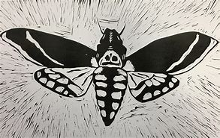  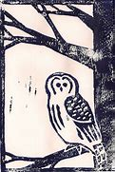 |  | Art History & Contemporary Art Connections:  Artist Name: Leopoldo Méndez  Méndez is from Mexico where he studied printmaking and founded “Taller de Gráfica Popular (TGP) (the Popular Graphic Arts Workshop)” (Art Institute of Chicago). His prints reflect his “philosophy of art as a means of activism and liberation for the people of Mexico” (Art Institute of Chicago).  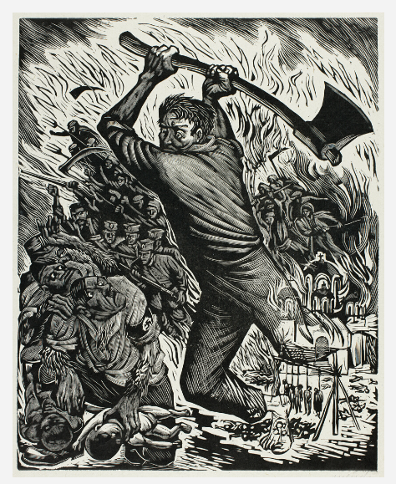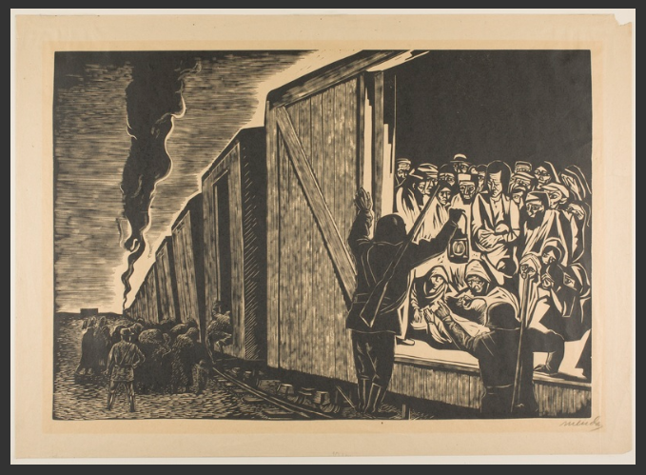  Artist Name: Elizabeth Catlett  Catlett was an african american sculptor and graphic artist well known for her empowering depictions of womon of color (LeGro 2012). Inspired by public art in Mexico, she did a series of Back women and what their lives really were at that time.  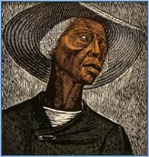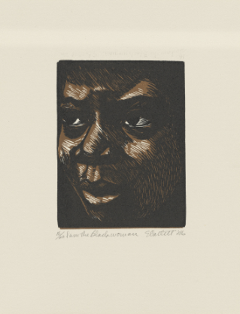  Big Idea:  Sharing Ideas
Materials:  -Linocut tool  -linoleum panel  -Ink  -Brayer  -Baren  -Glass or Plexiglas  -Paper or Fabric to print on  -Access to a sink to clean tools | Vocabulary:  Baren  Brayer  Positive Space  Negative Space  Relief printing  Symbols  Linoleum block | Scaffolding Assignments:  Intro:  The teacher will begin with a brief overview. Preferably some examples for students to pass around. Then, the teacher will conduct a brief carving demo to show how the tools are used, how to transfer a drawing to the linoleum, etc. Be sure to emphasize safety for this project. A summary skill share video will also be posted to canvas for anyone who missed the demo. Vredenburg Printmaking Skillshare Video.mp4.  Research:  Students will sketch out at least 3 ideas in their sketchbook prior to starting. Then transfer their images to the linoleum provided.  Students will investigate the historical application of printmaking as it relates to the visual transmission of ideas.  Linocut Printing: Repetition and Differentiation  Students will create a linocut stamp and 3 versions of this print to turn in with their stamps. | Summative Assessment:  Students will create mirror image sketches prior to printing, use carving tools to carve out the negative space, and create 3 positive prints using their carved linocut prints that convey a certain idea that is important to them.  Describe the theme of your piece. Then reflect on how printing, and the creation of multiples, can help facilitate information within a community. In 5-7 sentences total.

Standards:
AI.5 The student will identify communication and collaboration skills for the art studio, including safety procedures.
7. Understand visual arts as a form of community engagement Nurture a lifelong engagement with the arts as an integral component of communities and cultures.
AII.7 The student will identify ways that art can be used to address community needs.
Lesson Rationale:
Students will explore the potential of printing as a means of transmitting information. From a technical standpoint they will understand the use of positive and negative space and how it can be used to create a balanced, intriguing composition that elevates the importance of a meaningful idea. Further, the use of sharp tools will emphasize safety protocols.
Process Photos:

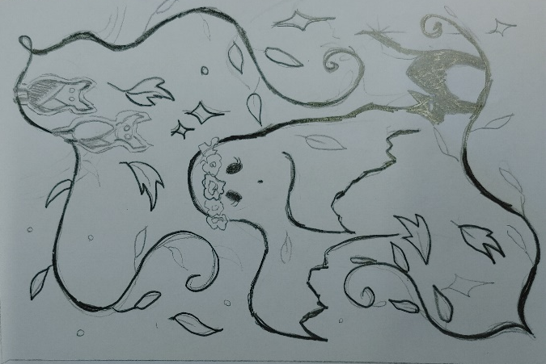
Step 1: Sketch out a design with a number 2 pencil (preferably not a mechanical pencil). Make sure the lines are nice and bold to transfer the image.

Step 2: Transfer the image from the paper onto the linoleum. This will be mirror-image of the sketch so take this into account when transferring words.

Step 3: Carve out the negative space using the carving tools (wherever you want the paper to show through).

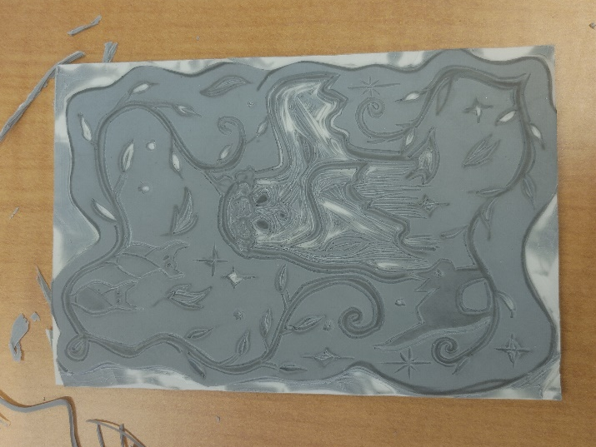

Step 4: Carve out the edges if you do NOT want it to have a square border.
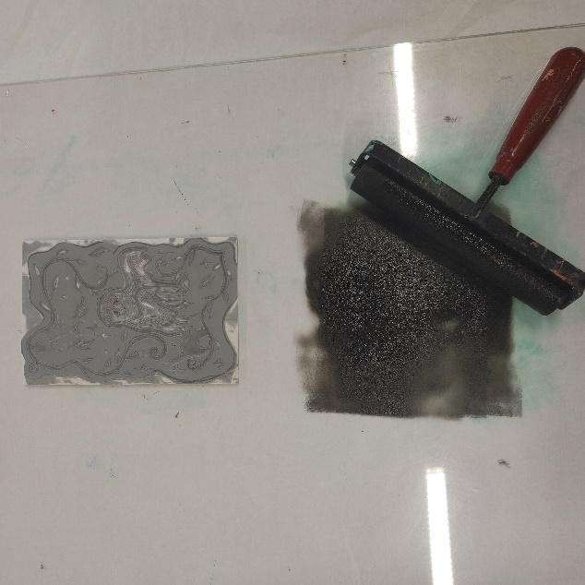
Step 5: Once you are finished carving, create a test print by pouring out a little bit of printing ink, and rolling your brayer in the ink. From multiple directions.

Step 6: Roll the ink evenly over the linocut. Make sure there is enough ink on the brayer.
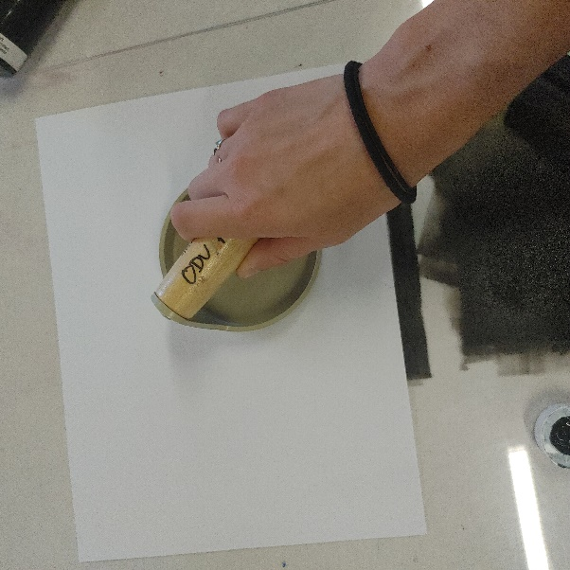
Step 7: place paper over the linocut and use a baren to apply even pressure so that the ink transfers evenly to the page.

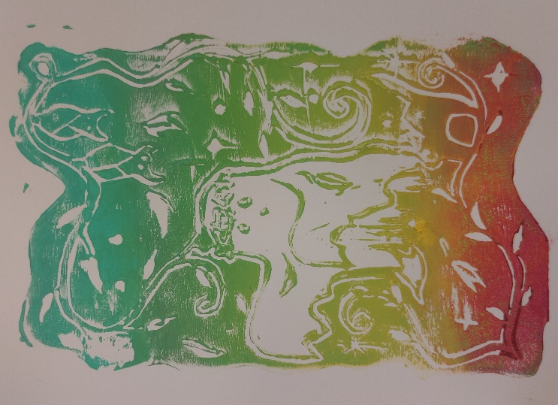
Step 8: Gently Remove the paper to reveal the final print (this can be done using different colors).

References
Art Institute of Chicago. (n.d.). Leopoldo Méndez. The Art Institute of Chicago. Retrieved November 3, 2023, from https://www.artic.edu/artists/35738/leopoldo-mendez.
LeGro, T. (2012, April 5). Conversation: The Life, Work and Legacy of Elizabeth Catlett, 1915-2012. PBS NewsHour. https://www.pbs.org/newshour/arts/conversation-the-life-work-and-legacy-of-elizabeth-catlett-1915-2012.

