Lesson Plan: Text as Art: Word Objects
Teacher Example:  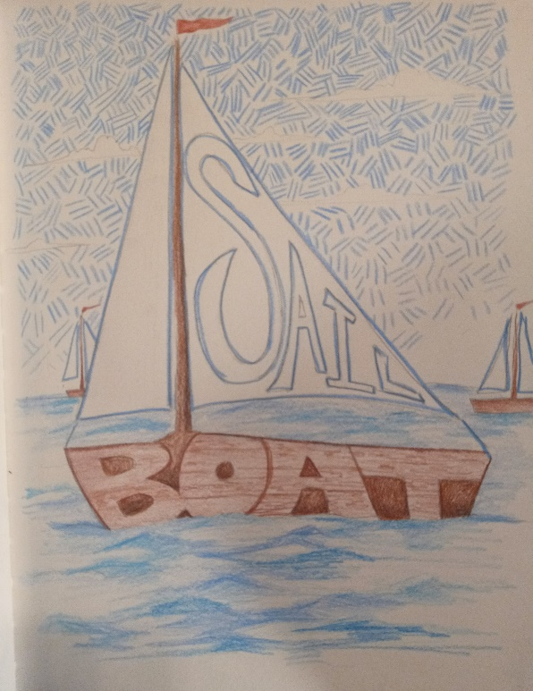  Lesson Examples: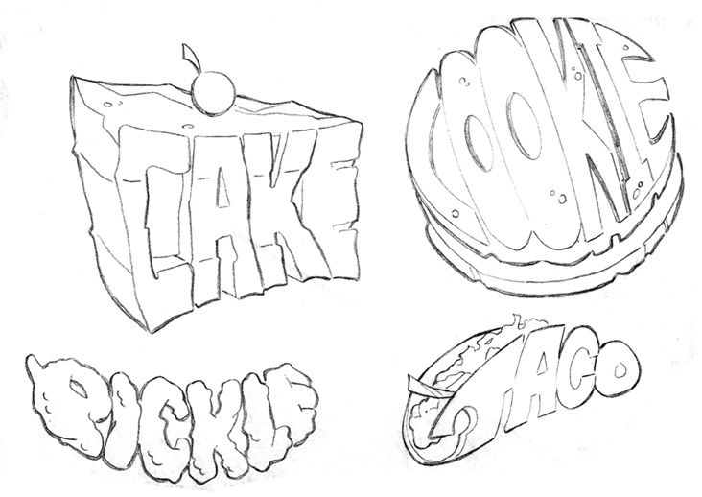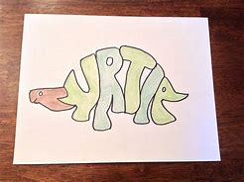 |  | Art History & Contemporary Art Connections:  Artist Name: BRUCE NAUMAN  Decription: Bruce Nauman is a contemporary artist popular in the 1960s for his broad use of materials that made him popular in the world of conceptual art. His use of text captures the viewers attention and draws attention to the message he presents; “ his work often centers on how slight changes in words can have a fundamental effect on meaning.”  Bruce Nauman | Biography, Art, Neon, Performance, Video, Clown Torture, & Facts | Britannica  https://mymodernmet.com/text-art-masters/  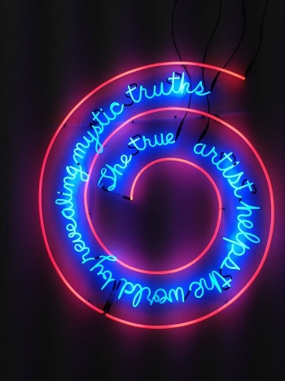  Artist Name: Steve Powers  Steve Powers uses bright colors in his murals throughout Philidelphia in the early 2000s. His work is described as “whimsical and thought-provoking, with an uplifting message, Powers plays off Philadelphia’s history of painted advertising.”  https://mymodernmet.com/text-art-masters/  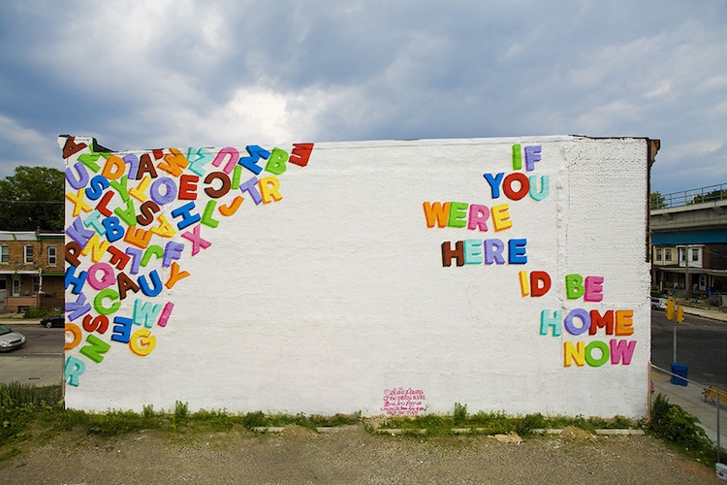  Big Idea:  Communication using both Visual and Written Language  Students will use creative thinking to construct a visual scene with a word object as their focal point. This reinforces understanding of the English language as well as art elements as a form of communication with viewers. Ie. color, shape, and pattern.
Materials:  Paper  Pencils  Colored pencils  Erasers | Vocabulary:  Shape  Literacy  Pattern  Monochromatic Colors  Complementary Colors  Block Letters | Scaffolding Assignments:  Intro:  The teacher will introduce the lesson with a short clip from word world to provide examples of the project. As well as a brief discussion that highlights the use of language in visual art.  Practice:  Students will practice drawing their first name in block letters on the back as a form of scaffolding this combined form of writing and drawing.  The teacher will also conduct a brief colored pencil tutorial on how to color lightly and gently blend colors.  Name of Activity:  Word Art!  Students will draw an object of their choice made up of letters in order to connect the visual language to written word. | Summative Assessment:.  Students will use the elements of art (specifically color, shape, and pattern) to draw a word object with surrounding scenery. Thus, they will combine literacy and art to create meaning.

Lesson Rationale:
It is important for students to understand that both art and language can be impactful, especially when combined. They will also understand that art and language do not have to be exclusive when the class is introduced to the contemporary artists Steve Powers and Bruce Nauman. This enforces the idea that art and literacy both create meaning as a form of communication with viewers. Additionally, this activity also reinforces previous skills such as spelling and writing.
Process Photos:
Step 1: Gather all the materials you will need for the assignment: paper, a pencil, an eraser, and some colored pencils.
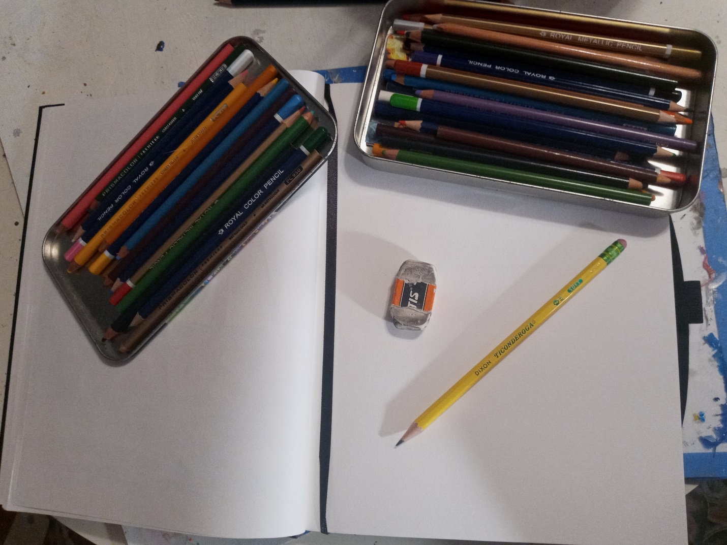
Step 2: Sketch shapes out lightly in pencil so that you can easily erase them and color over them later.
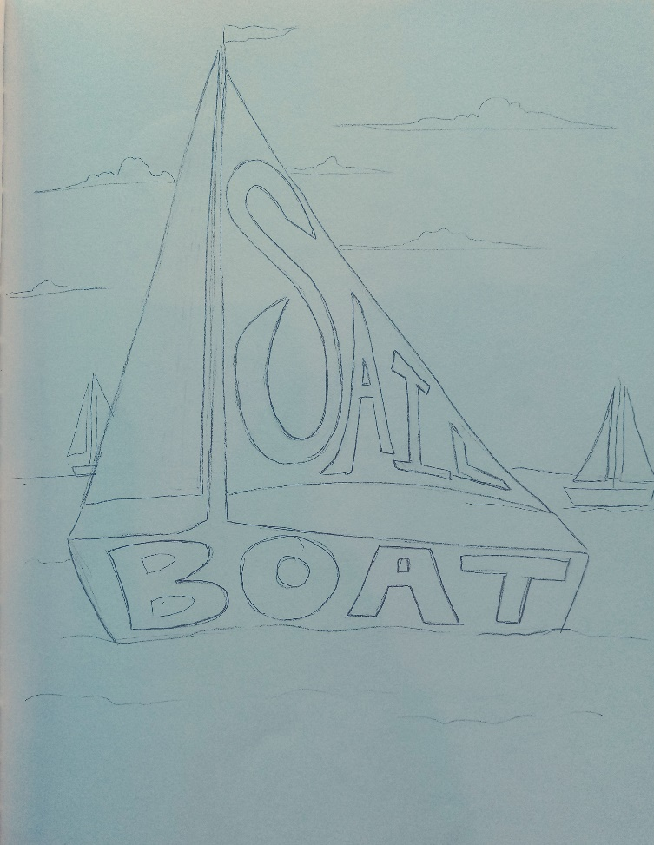
Step 3: Once you are done sketching, start to color the background with your colored pencils. Use at least one repeating pattern.

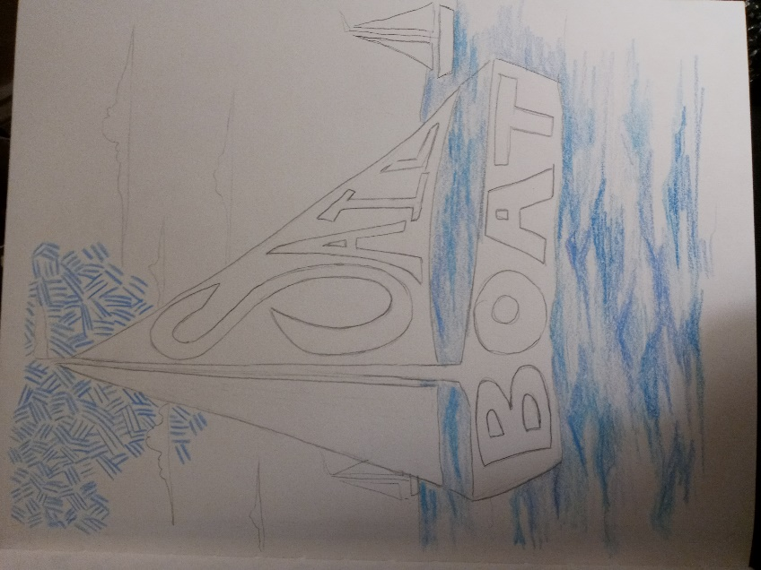
Step 4: Complete the pattern and begin outlining your shapes and letters in colored pencil.
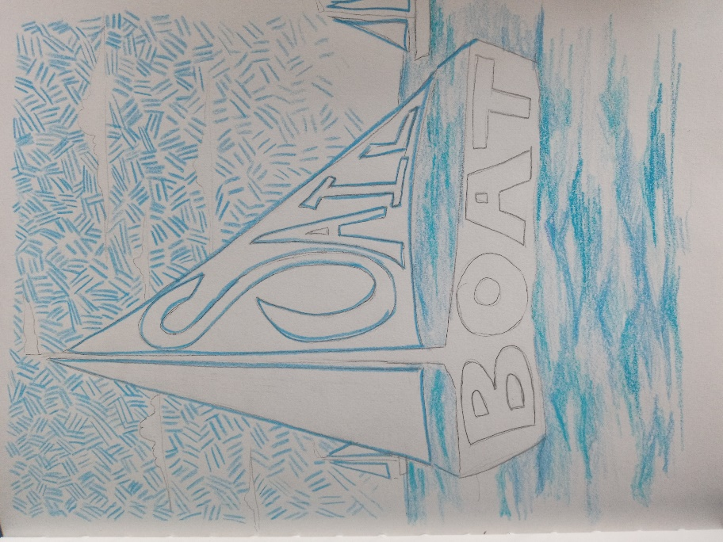
Step Five: Continue coloring other shapes. If you need to re-work any letters, it must happen before you begin coloring.
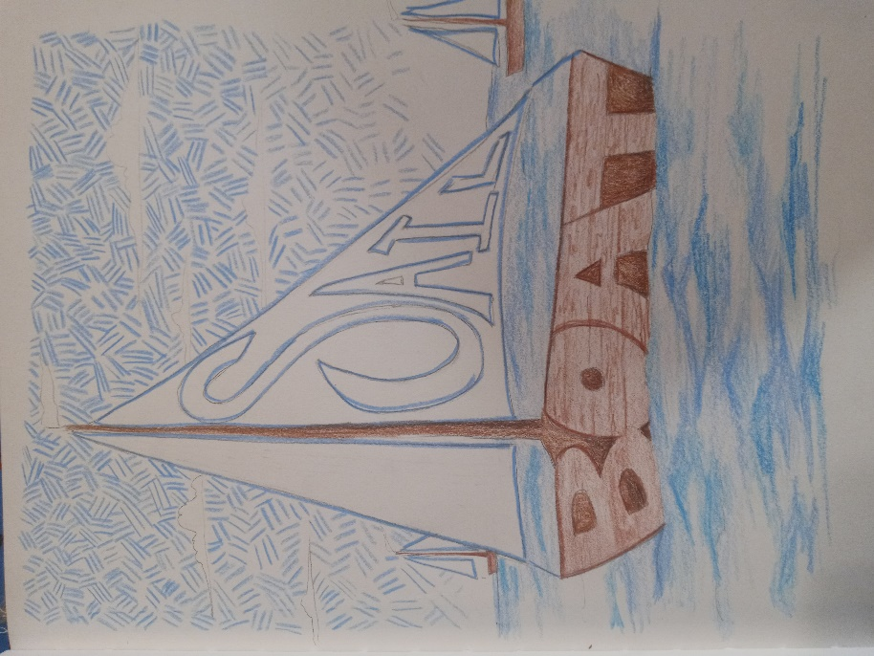
Step 6: Add final details and textures like the wooden siding of the boat and colorful flags!
