Lesson Plan: Fibers Synthesis
Grade Level: 12th
Teacher Example:  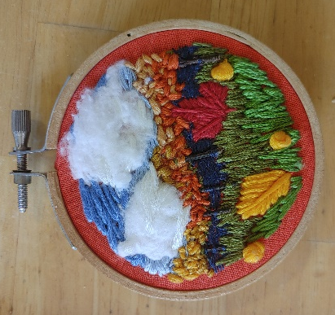  Lesson Examples:  Abstract Example  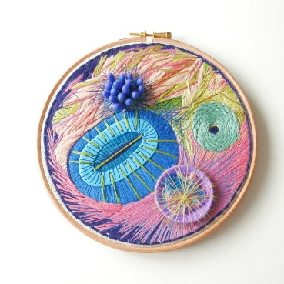  Representational example: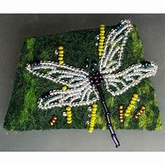 |  | Art History & Contemporary Art Connections:  Artist Name: Ágnes Herczeg  Description: Ágnes Herczeg is an artist from Hungary who uses both wood and fiber techniques to create small scale whimsical forms (Herczeg 2023).  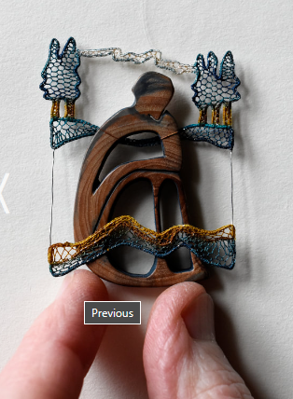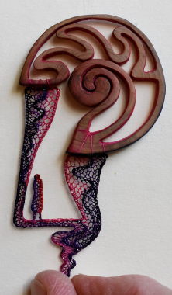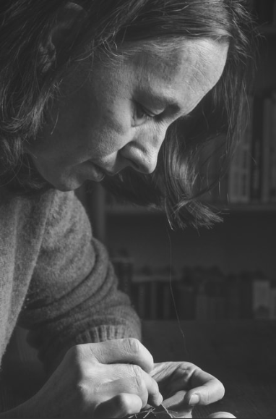  Artist Name: Ana Teresa Barboza  Description: Ana Teresa Barboza is a Peruvian textile artist. She “creates three-dimensional fibre art that spills out of the canvas and into the gallery space” (Wells, 2019).  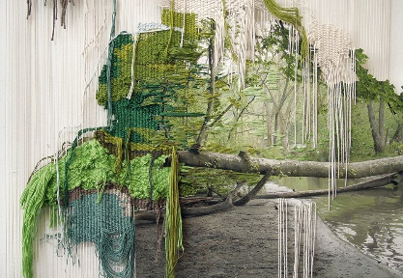  Big Idea:  Synthesis/Pattern
Materials:  -Embroidery Thread  -Found objects (cotton balls twigs)  -Fabric background  -Embroidery Needle  -Hoop  -Sketchbook  -Writing Utensil | Vocabulary:  -Embroidery hoop  -Multidisciplinary art  -Freehand Embroidery  -Running stitch | Scaffolding Assignments:  Intro:  The Teacher will introduce the lesson with a quick tutorial video.  The teacher will also walk students through the process of threading a needle, separating string, and incorporating other objects into their projects.  Research:  Students might need to find and inspiring reference photo prior to starting their sketches. This will take place on their Chromebook during the initial start of the project.  Scaffolding: We will take a found object field trip outside. Students will also have the option to bring items from home.  Name of Activity: Found Object Embroidery Project  Students will incorporate found objects such as beads or natural materials into their embroidery projects. | Summative Assessment:  Students will each experiment with embroidery thread and incorporate found materials into their fibers project. The Subject is up to the students, but landscapes work exceedingly well.

Standards:
AIII.15 The student will demonstrate technical skill and independent thinking in the use of media, techniques, and processes to achieve desired intentions in works of art and design.
AIV.16 The student will select artmaking media and techniques to support personal creative intentions.
Lesson Rationale: This lesson is important because it not only allows students to think about pattern but also how to combine seemingly unrelated materials/objects in order to synthesize a new resulting image. By combining different materials and weaving them together through embroidery, students will create a unified image; therefore, they will expand their artistic skills beyond the typical 2D surface and materials,
Process Photos:
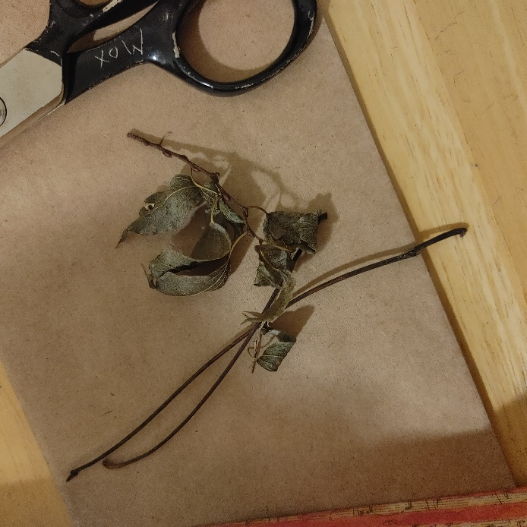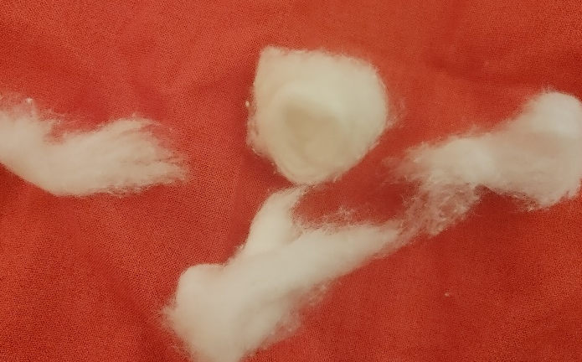
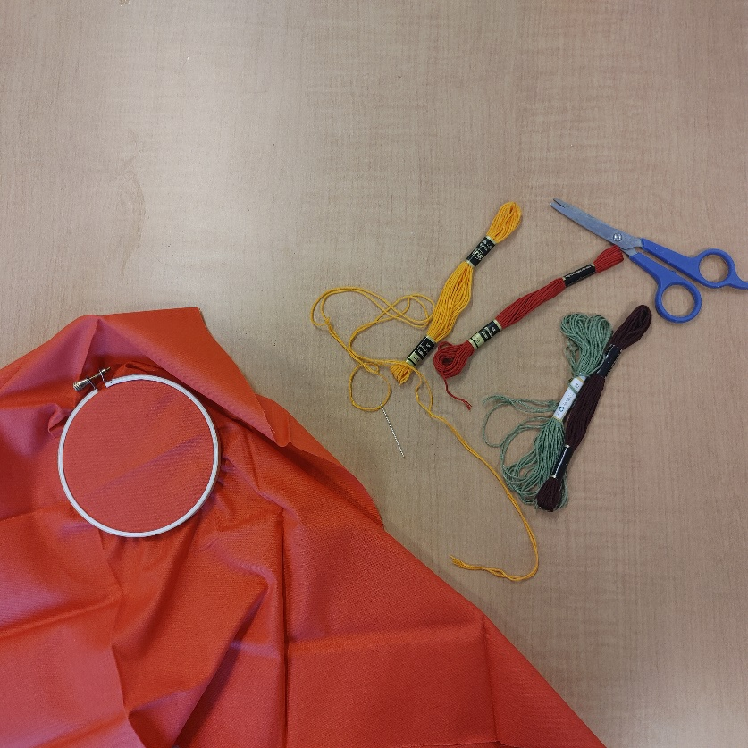
Step 1: photos 1, 2, and 3, collect your materials, in this case fabric, a hoop, assorted embroidery thread, scissors, cotton balls, twigs etc.
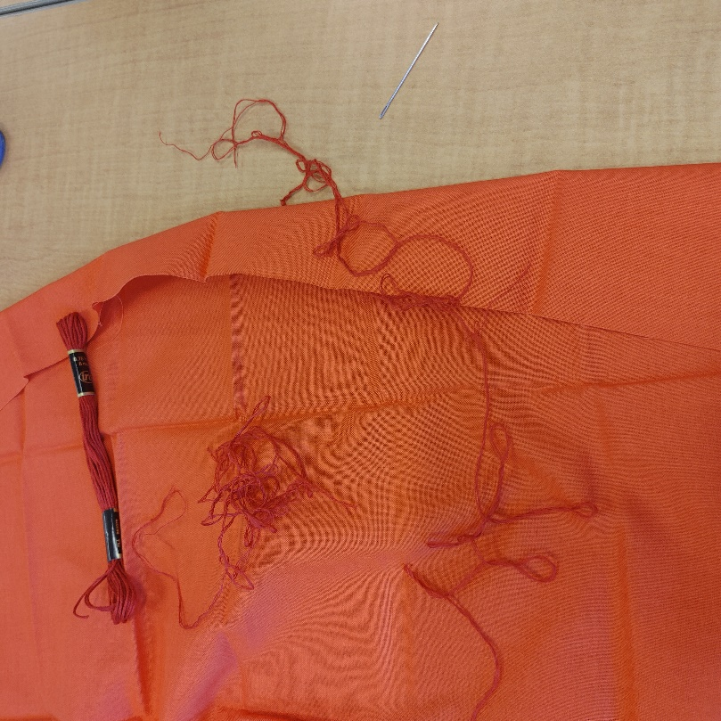
Step 2: For details, separate the threads of the embroidery thread.
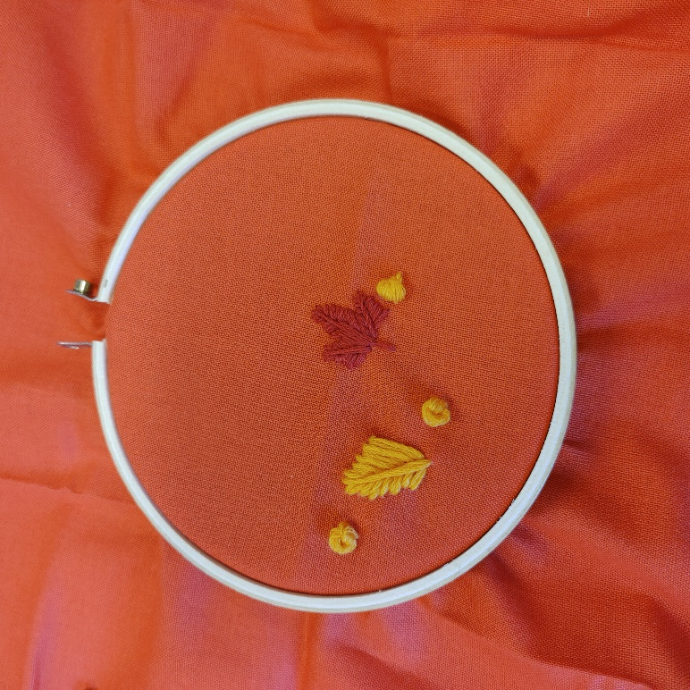
Step 3: I like to start with the focal points, so I knew where to build my composition from. Using a freehand technique, create your main subjects.
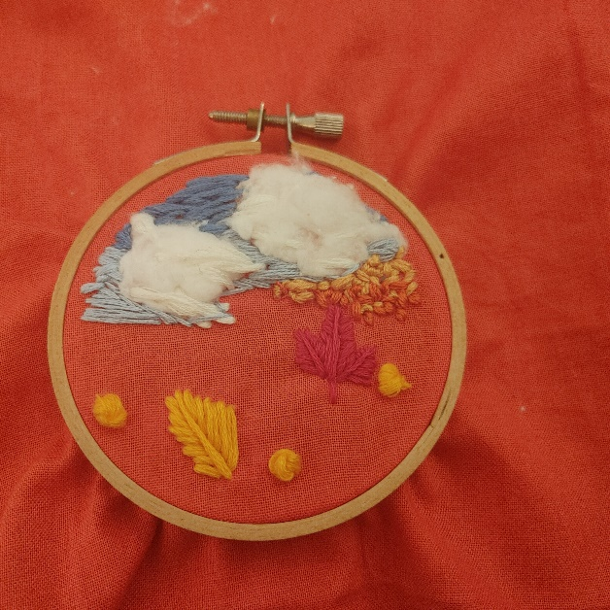
Step 4 and 5: Add in some longer, different colored strands to fill in larger areas of color. Tack on the cotton ball clouds with a few strands of white embroidery thread. The white does not use the separation technique, it helped to have all strands to hold the cotton material in place.
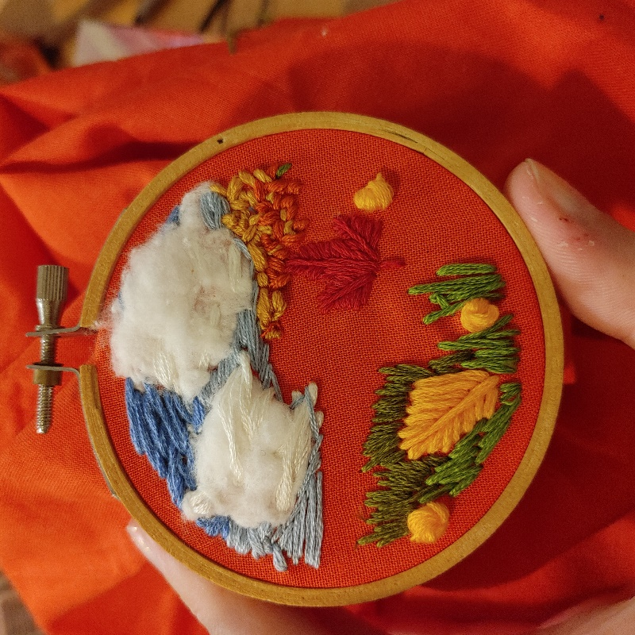
Step 6: Begin adding blades of grass, it helps to follow the logical directionality of the individual blades and keep each line of thread close together so the fabric does not show through.
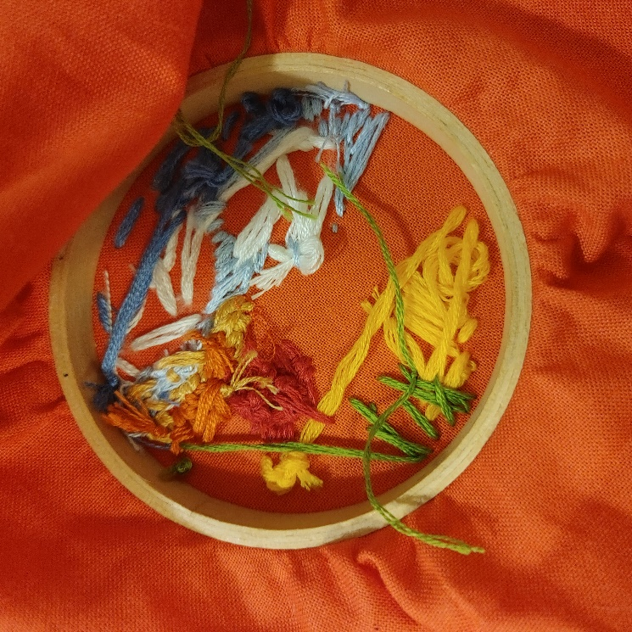
Step 7: Check in on the back periodically when knotting each color.
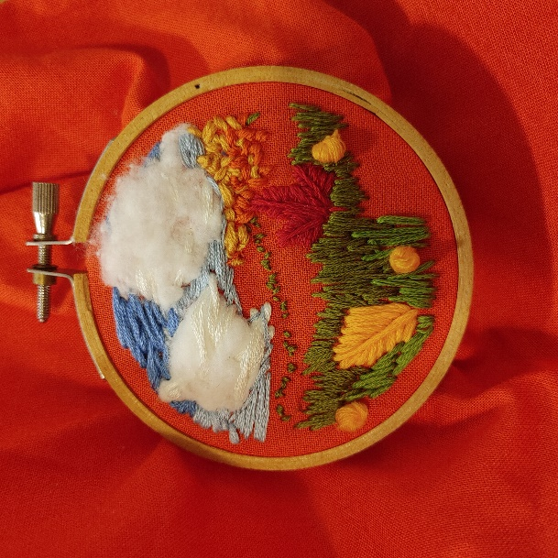

Step 8: Continue filling in leaves and grass since we are using the same green thread for both of these aspects and they are positioned close together.

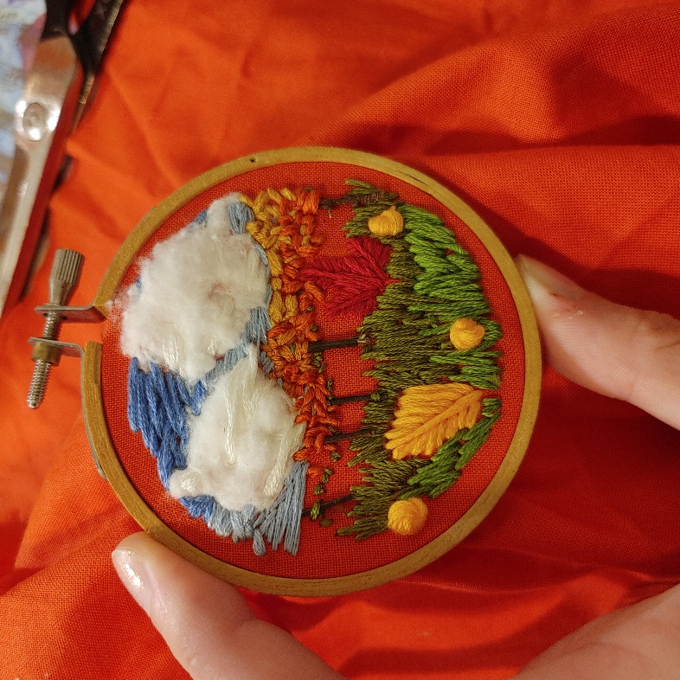
Step 9: Use scissors to cut up twigs for tree trunks and secure the top and bottom with one stitch in the corresponding color. Ie. Orange leaves at the top, green grass color at the bottom.

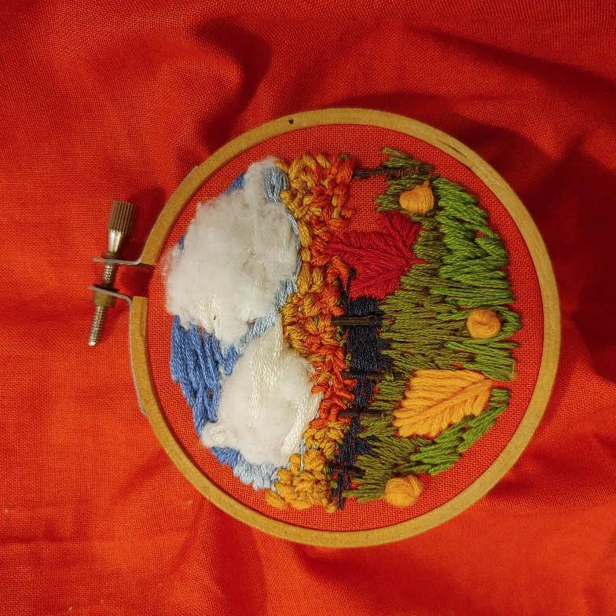
Step 10: Begin filling in the distant darkness with navy blue thread. Separate the threads for this, as the thinner thread provides an implied distance for the viewer, just as the bolder, 6-strand stitches created the impression of being closer to the viewer.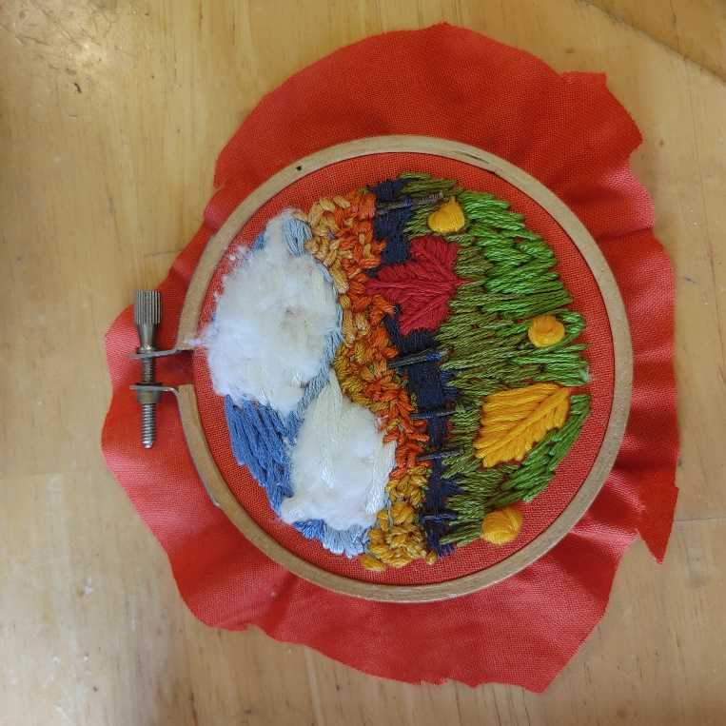
Step 10: Begin filling in the distant darkness with navy blue thread. Separate the threads for this, as the thinner thread provides an implied distance for the viewer, just as the bolder, 6-strand stitches created the impression of being closer to the viewer.

Step 11: Cut off the excess fabric (this does not have to be laser-like precision).
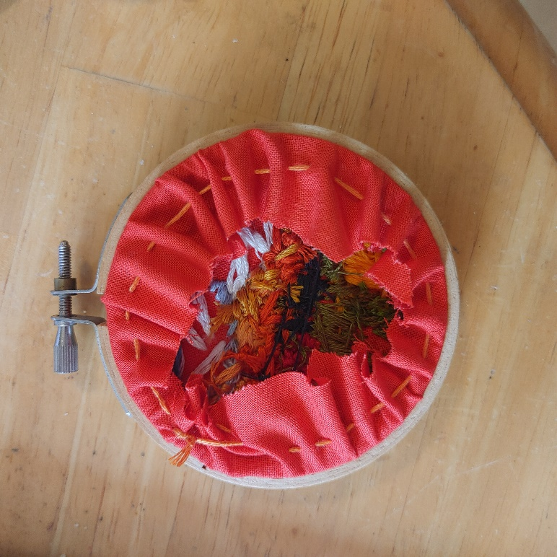
Step 12: Using a simple running stitch, tie up the excess fabric in the back to make the front pristine.
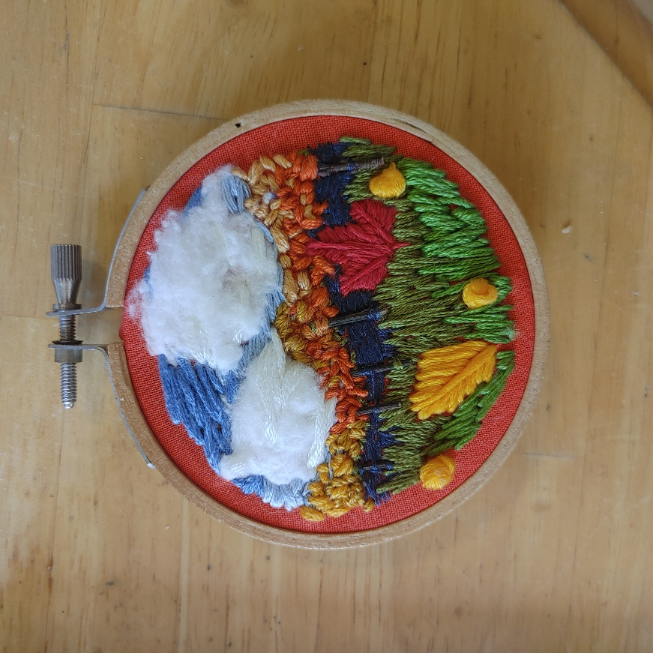
Step 13: Final product, can be used as a window decoration, ornament, etc

References
HERCZEG, Á. (2023). Ágnes Herczeg. ÁGNES HERCZEG; Weebly. https://www.agnesherczeg.com/
Wells, K. (2019, February). Ana Teresa Barboza Contemporary Embroidery Fibre Art. THE FIBER STUDIO. https://thefiberstudio.net/ana-teresa-barboza/

