Lesson Plan: Life Science Through Observational Drawing
Grade Level: 4
Teacher Example:  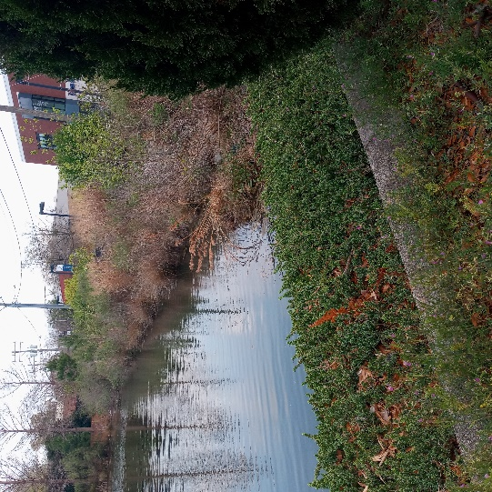  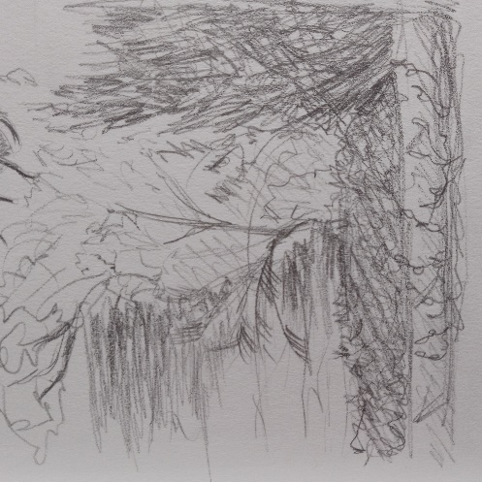  Lesson Examples:  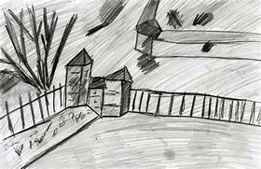  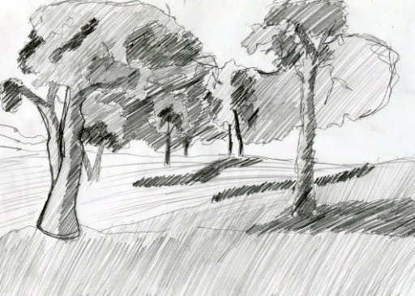 |  | Art History & Contemporary Art Connections:  Artist Name: Luke Jerram  Decription: This artist creates sculptures and installations internationally. For a Belin exhibit called Glass Microbiology, he combines art and science through his use of glass to depiect miscroscopic particles on a larger, beautiful scale.  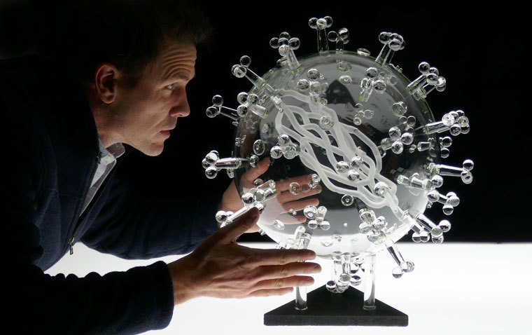  Artist Name: Paul Mordetsky  Decription: Paul says that he is “interested in landscape for metaphoric reasons more than for purely descriptive ones – that is, I like the poetry of big space with big forms in big light.” This furthers the idea that art is not just art, there is the potential for science and English to be present as well. He uses both painting and drawing to communicate these landscapes to the viewer.  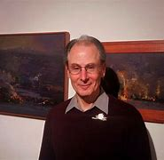  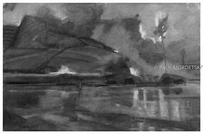  Big Idea:  Art does not exist separately from other disciplines. For instance, Science and Art are not mutually exclusive, the world around us is full of harmony that can be expressed both scientifically and artistically.
Materials:  Sketchbook  Pencils  Erasers  Outdoor location to observe Nature. | Vocabulary:  Perspective  Texture  Line  Line weight  Hatching  Crosshatching  Value | Scaffolding Assignments:  Intro:  The teacher will refresh the students on the ideas of life science including ecosystems and energy transfer within.  Research:  Students will participate in the refresher discussion in class and test their knowledge of life science.  Name of Activity:  The Science of Observational Drawing  Students will use observational skills to draw a natural landscape and use scientific background knowledge to explain the significance. | Summative Assessment:  Students will journey outside with the teacher and find a spot to draw. They will use pencil and paper to sketch the scene in front of them, then return to class to discuss the ecosystem that might exist in the environment of the drawing.

Standards: Living Systems and Processes (Science, 4th Grade)
4.2 The student will investigate and understand that plants and animals have structures that distinguish them from one another and play vital roles in their ability to survive. Key ideas include
a) the survival of plants and animals depends on photosynthesis;
b) plants and animals have different structures and processes for obtaining energy; and
c) plants and animals have different structures and processes for creating offspring.
4.3 The student will investigate and understand that organisms, including humans, interact with one another and with the nonliving components in the ecosystem. Key ideas include
a) interrelationships exist in populations, communities, and ecosystems;
b) food webs show the flow of energy within an ecosystem;
c) changes in an organism’s niche and habitat may occur at various stages in its life cycle; and
d) classification can be used to identify organisms
ART Standards: Grade 4:
4.14 The student will use a variety of lines and shading techniques to create observational drawings.
4.17 The student will create works of art that connect ideas, art forms, or cultural themes to personal experiences.

Lesson Rationale:
Even adults tend to separate “left” and “right” brain activities such as Science and Art. However, it is important to acknowledge that there is an overlap and the harmonies of both adisciplines. Science can help one understand the natural world, but art allows one to understand and express their response to it. By combining these seemingly different areas of study, students will develop creative thinking skills that are applicable to other areas of study and experience.
Process Photos:
Step 1: Gather Materials, in this case, paper, pencils, and erasers.
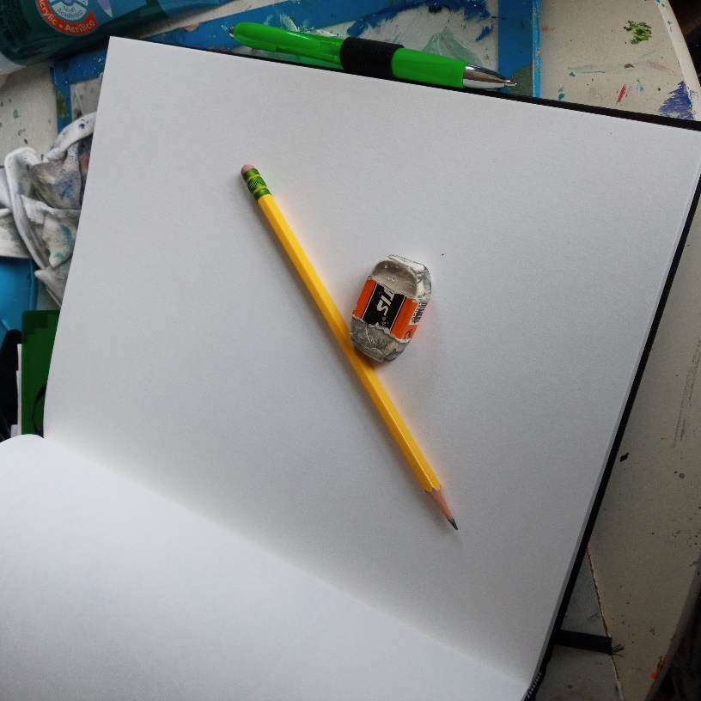
Step 2: Pick a spot to draw and take a moment to pick WHAT you’re going to draw. Begin by really looking at the shapes, flowers, and insects that are present.

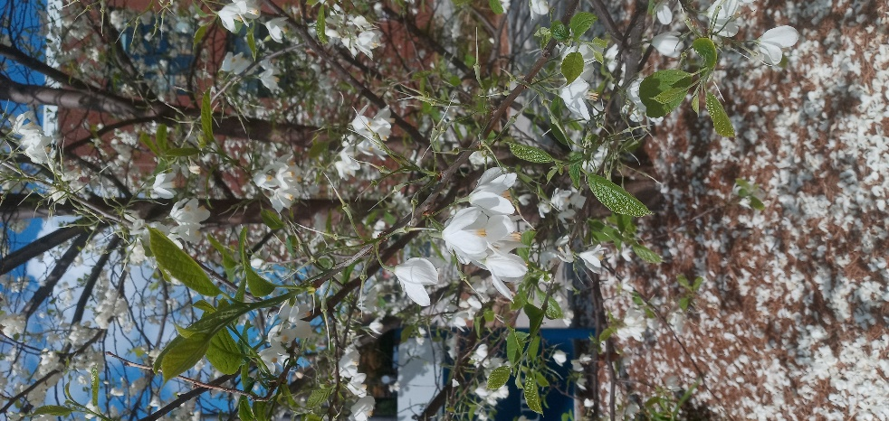
Step 3: Using pencil, start drawing those basic shapes. Think critically about how bees and butterflies are interacting with the flowers and why. What would happen if they suddenly stopped pollinating trees like this one?
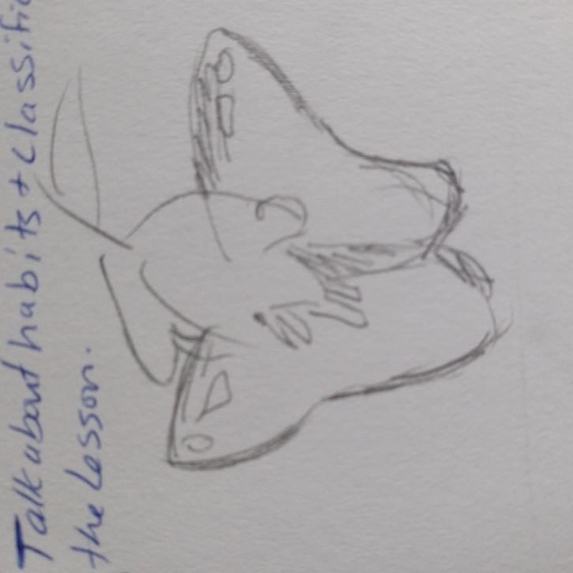
Step 4: Keep looking! Try not to overuse your erasers, instead draw lightly and purposefully to capture the right segments of the bees and flowers we see.
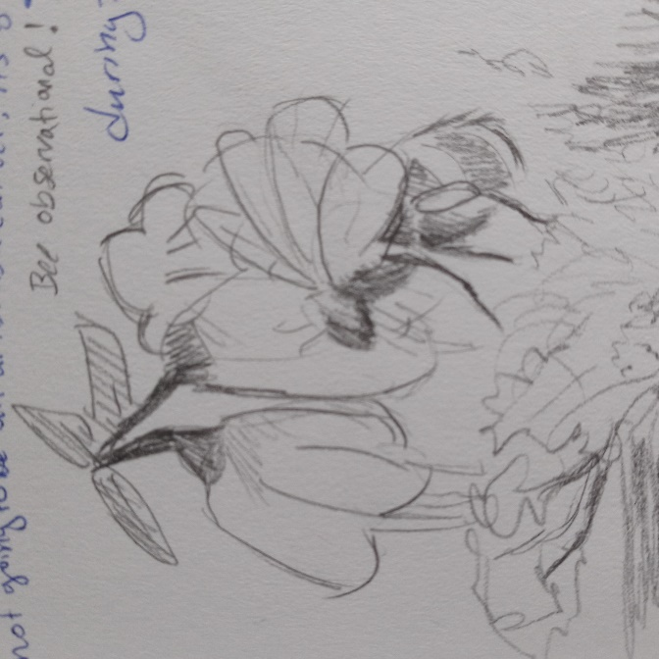
Step 5: Find another location where we can draw a larger ecosystem/landscape (not just one bee!).
Step 6: Really pay attention to where the darkest and lightest parts are. What textures do you see? Use hatching and crosshatching to create textures. 