Lesson Plan: Stupendous Secondary Stop Motion!
Grade Level: 11th
Teacher Example:  🍄 Rachel Nicole 🍄  Lesson Examples:  'Bowler' | CEL ANIMATION (shilstonearts.com)  PAPER CUTS by Righteous Robot - YouTube  Shorts | zaramella.com.ar |  | Art History & Contemporary Art Connections:  ROBBIE SHILSTONE is based in Los angeles and specializes in digital animation. He has a wide rage of styles and an exceptionally colorful portfolio.  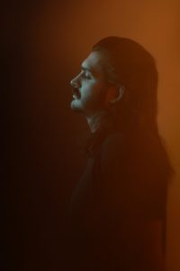  JULIAN CURI is Cuban American storyteller, based in northern Virginia. Whether through art animation or a combination of the two, he strives to bothe “entertain and inspire.”  JUAN PABLO ZARAMELLA is an Argentinian director, animator and creator. He is a prolific artist working on more than 10 shorts and 2 TV series.  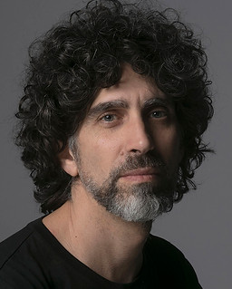  Big Idea:  Patience
Materials:  A Phone Camera  A free app for stop motion editing  A couple objects of the students’ choice to move for the animation | Vocabulary:  Editing  Stop Motion Animation  Paper motion Animation | Scaffolding Assignments:  Intro:  The teacher will show a video that includes a brief breakdown of how stop motion animation works.  Research:  Students will jot down story ideas in their sketchbook  They can also browse examples on their devices for inspiration.  Stop Motion Animation Narrative  Students will tell a visual short story using stop motion animation. | Summative Assessment:  Students will work in class using their phones to snap pictures of found objects to create the illusion of movement using multiple frames. They will create a 1-minute video that shows a brief interaction with the ‘characters.’

Standards: AII.10 The student will identify how digital media, and technology tools can be used to create, edit, and present works of art.
Lesson Rationale:
This lesson offers students the opportunity to exercise patience with their craft, in this case, frame by frame picture taking to create motion with still life objects. Additionally, this will create an awareness that each action, despite it being very small, in important to the overall flow/success of the video overall. By cutting corners while taking their pictures, they risk a choppy effect and impact in the final results of their videos.
Process Photos:
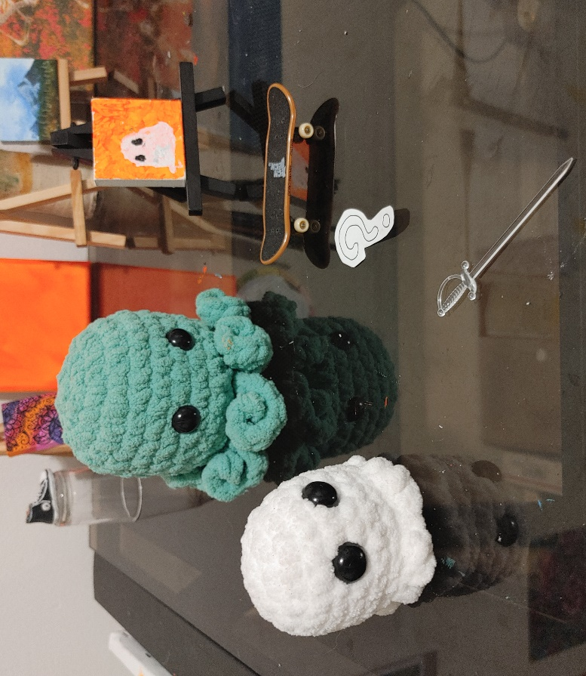

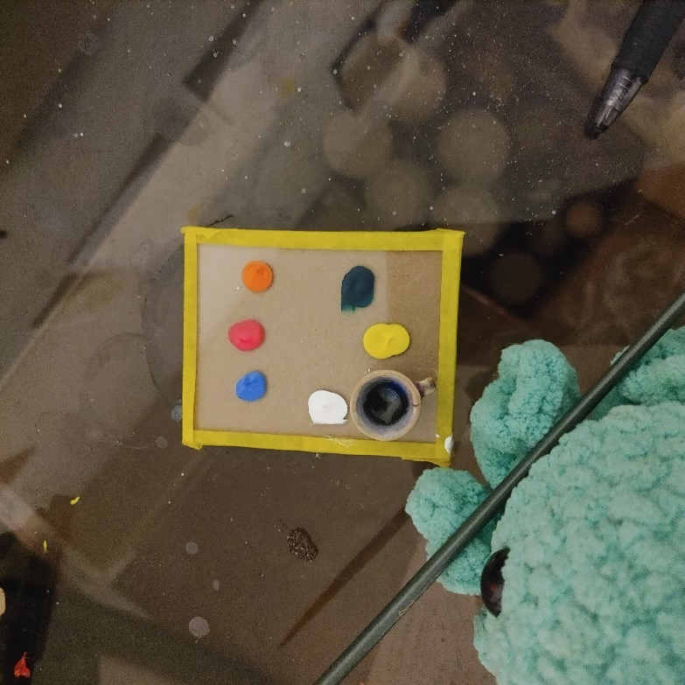
Images 1 and 2: Collect the objects used to create your stop motion video.

Image 3: Make sure you use a consistent light source so that the lighting doesn’t vary due to time of day within your scene. In class, the light source wil be the overhead lights.

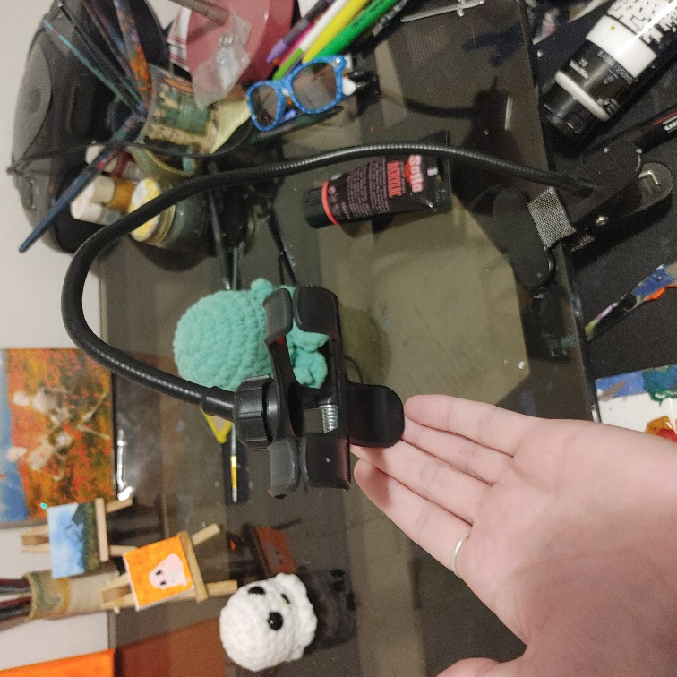
Image 4: Use a tripod, clamp, or other stabalizing instrument so that the angle stays the same between frames. If working in class rest your phone up agianst your chromebook or backpack for stability.

Image 5: Dowload a free stop motion app for your phone.
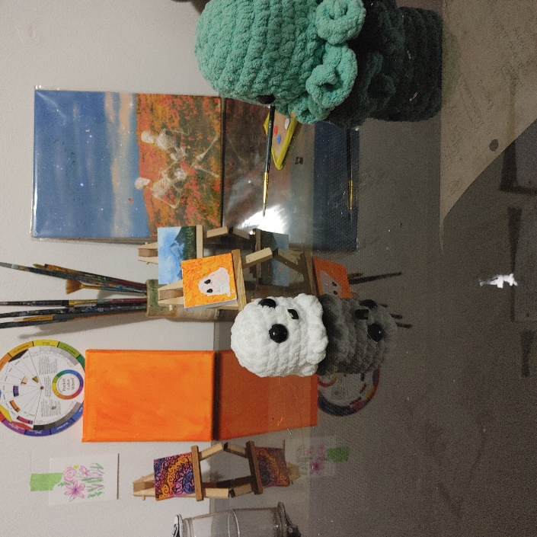

Image 6: move characters individually between frames to create the illusion of movement.
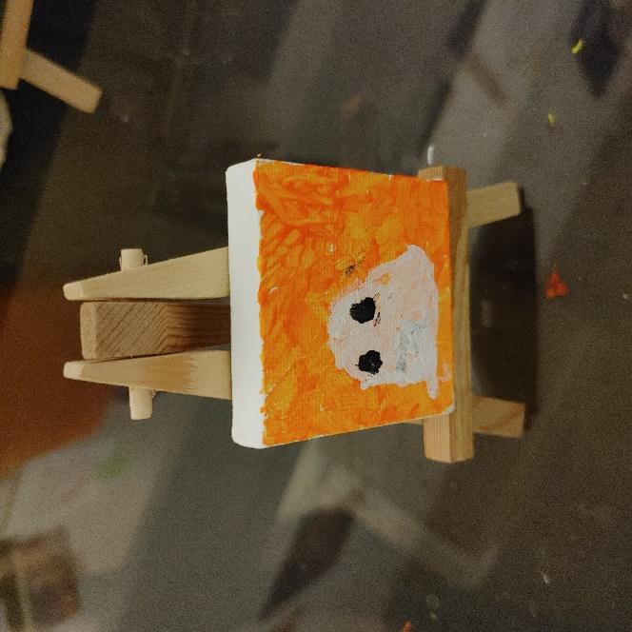

Image 7: Get creative! Final result of the stop motion painting, painted frame, by frame for the movie.
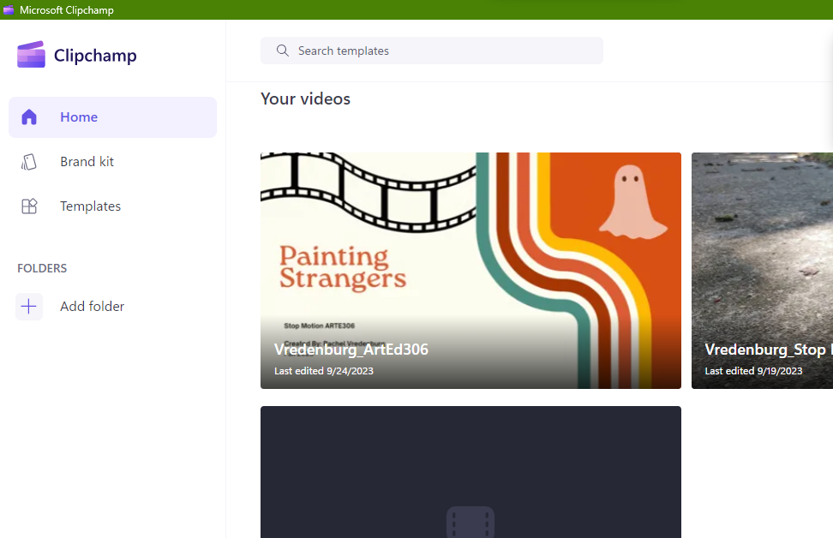
Image 8: Using a free software like Clipchamp, edit your fames, or overlay audio to add pizzaz!
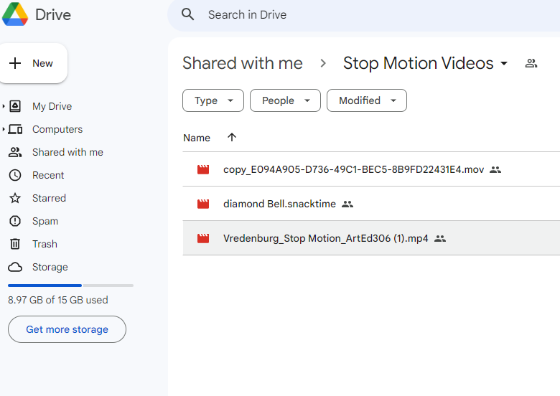
Image 9: Export your video from your video editing software and upload it to our google drive in-class presentation!

