Lesson Plan: Mini Macrame: Pattern of Persistence
Grade Level: 9th
Teacher Example:  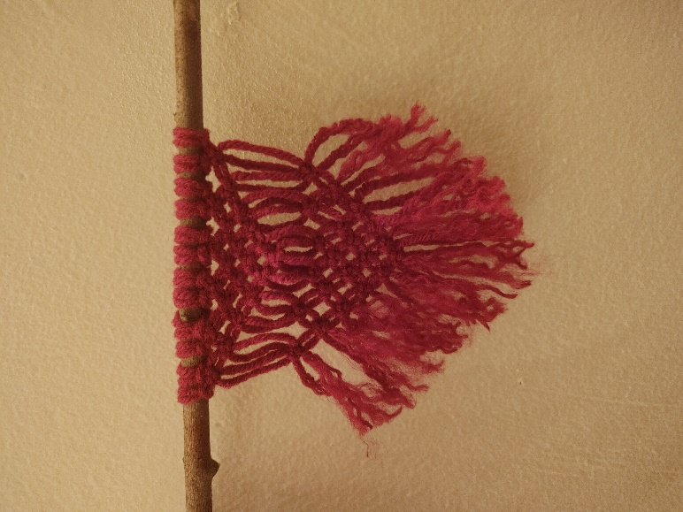  Lesson Examples:  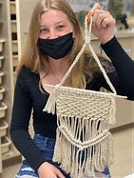  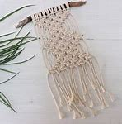 |  | Art History & Contemporary Art Connections:  Artist Name: Michael Gabrielle  Michael Gabriel is a queer artist based in San Fransisco who is“all about building sustainable systems and creating safe spaces” (Gabrielle 2023). They use a larger scale version of this project.  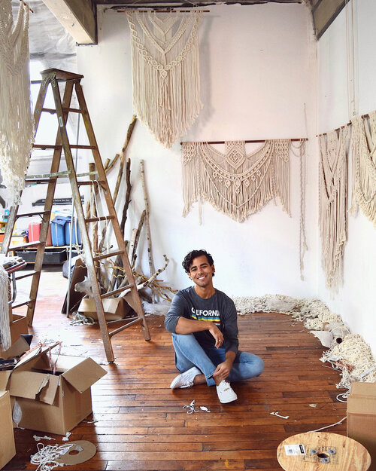  Sandra de Groot  Based in the Netherlands, Sandra de Groot, also known as Atelier Chaos, uses textiles to tell a story by “exploring craft, technique and strategy in both cultural and architectural ways” (de Groot 2019). This shows the extent to which these techniques can be expanded.  Big Idea:  Repetition and Symmetry
Materials:  -Found sticks or dowel rod to begin for the support/hanger  -Variety of yarn  -Scissors  -Basic knotting handouts  -Ruler | Vocabulary:  -Macrame  -Overhand Knot  -Square Knot  -Half Hitch Knot  -Weaving  Cow Hitch knot | Scaffolding Assignments:  Intro:  Introduce the lesson using some tutorial videos of different knotting options so that students may choose one.  Fibers Photos\Vredenburg Skillshare Fibers.mp4  Research:  Students will draw 3-4 thumbnail sketches in their sketchbooks prior to starting their projects.  Name of Activity: Mini Macrame Wall Hanger  Students will use at least 1 knotting technique to create a mini wall hanging and reflect on the importance of repetition and persistence in art. | Summative Assessment:  Students will begin with a linear support such as a stick or dowel rod, and use yarn to weave a miniature macrame wall hanger that incorporates one of several knotting techniques introduced in class. This will be completed in class during the week.  Finally, students will write a reflection paragraph on the importance of practice and repetition as it relates to one’s craft.

Standards:
AII.4 The student will formulate a definition for art and defend that definition in relation to objects in the world. (As it relates to fibers)
AII.15 The student will demonstrate proficiency, skill, and control in the use of media and techniques.
Lesson Rationale:
Students will exercise patience and repetition as they repeat the pattern of knotting used in this project. They will also reflect on the importance of repetition and persistence when achieving a final goal and the importance of practicing a craft as they with undoubtedly improve from their first knot to their last knot of the project.
Process Photos:
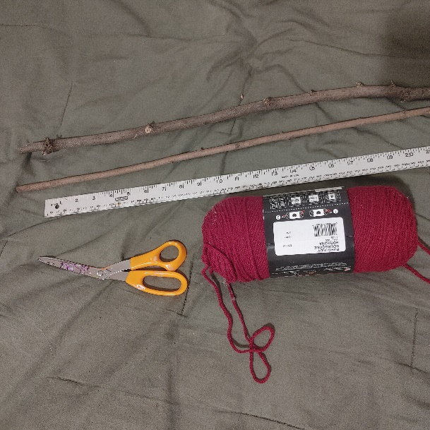
Step 1: Gather a linear support (stick or dowel rod), yarn, and ruler or yard stick, scissors, and a comb.
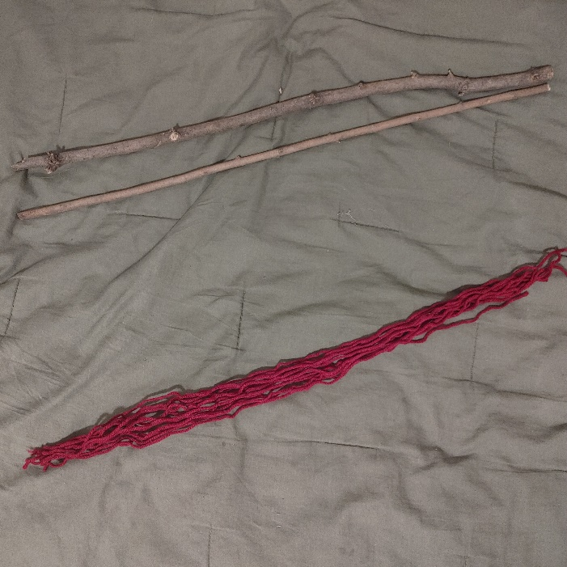
Step 2: Cut 12 pieces of string that are equal in length. The number of strings should be divisible by 4.
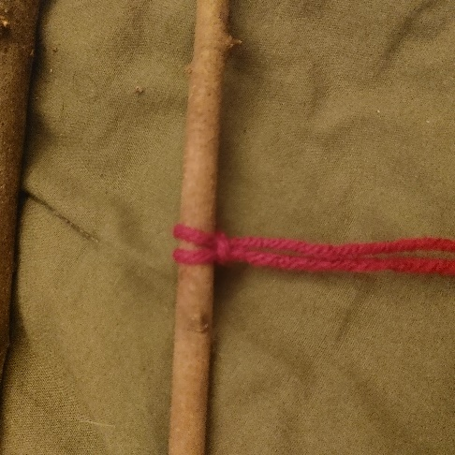
Step 3: Loop a cow hitch knot over tie all pieces of string around the support so that they hang evenly from the stick.
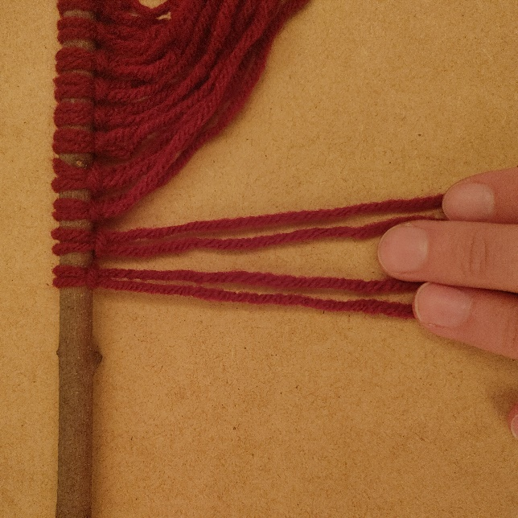
Step 4: once you have all pieces secured, separate the first 4 stands for a square knot. The skill-share video explains the exact process of the square knot.

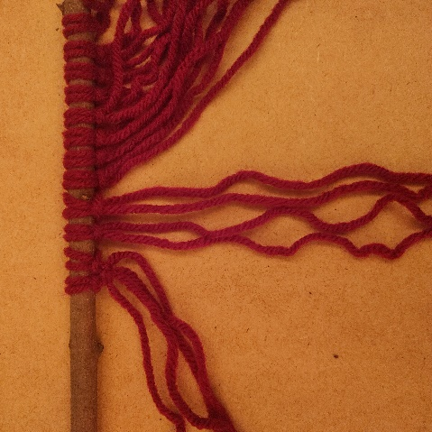
Step 5 and 6: continue the process of square knots all the way across the first row. At the start of the next row, I began my first square knot with stands 3,4,5, and 6 so that the pattern tapered in a triangle shape.

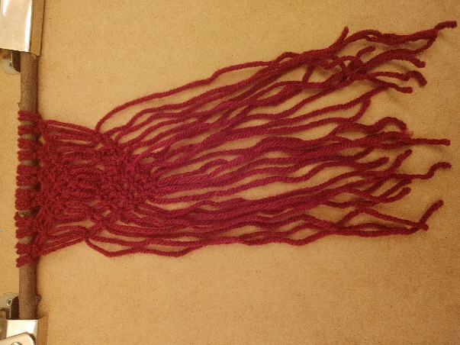
Step 7: Once the first triangle pattern is complete, I began another layer for visual interest, using the same pattern and technique so that there are now 2 triangles.
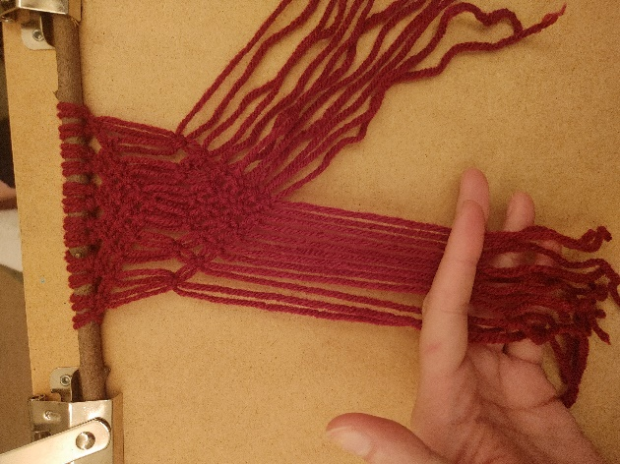
Step 8: Next, I cut the excess yarn off in a diagonal pattern for visual consistency.
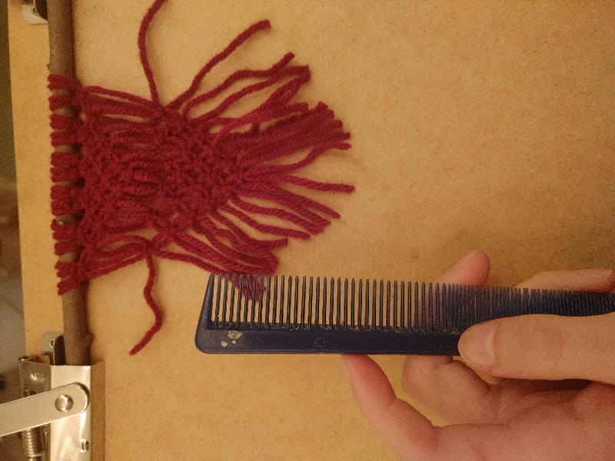
Step 9: Using the comb, I brushed out the threads for variety of texture.
Step 10: The Final piece hanging from the stick
References
de Groot, S. (2019). Atelier Chaos - Sandra de Groot. Atelier Chaos - Sandra de Groot. https://atelierchaos.com/
Gabrielle, M. (n.d.). About. Michael Gabrielle. Retrieved October 23, 2023, from http://michaelgabrielle.com/about

