Lesson Plan: Gelli Printing: Exploration in Composition!
Grade Level: 7th
Teacher Example:  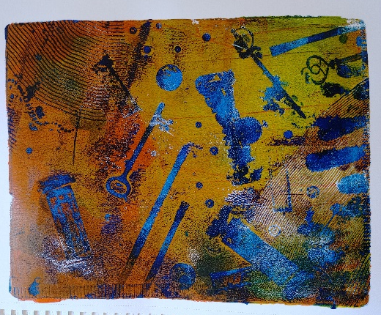  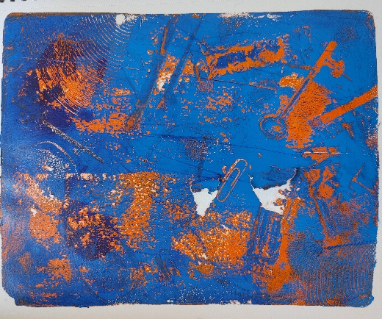  Lesson Examples:  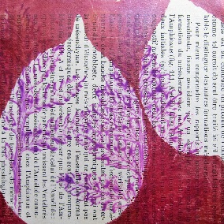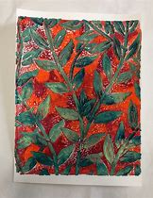 |  | Art History & Contemporary Art Connections:  Artist Name: Carla Sonheim  “Carla Sonheim is a painter, illustrator, and creativity workshop instructor known for her fun and innovative projects and techniques” (Sonheim). Based in Seattle, much of her works focus on the abstraction and creative thinking required for printing.  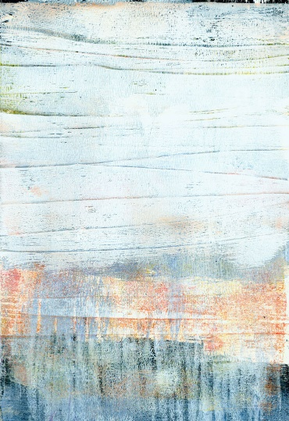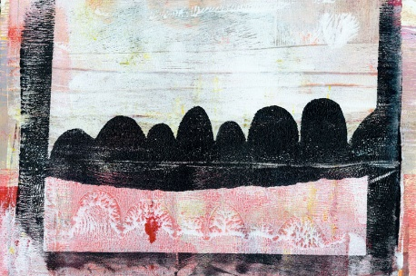  Artist Name: Delita Martin  “Delita Martin is a master printmaker. From monoprints to relief prints, Martin incorporates a little bit of everything. Some of her work might even be characterized as mixed-media printmaking” Born in Texas she creates large scale prints that explores generational connections and personal memory.  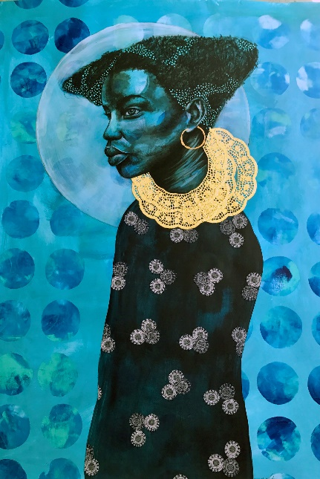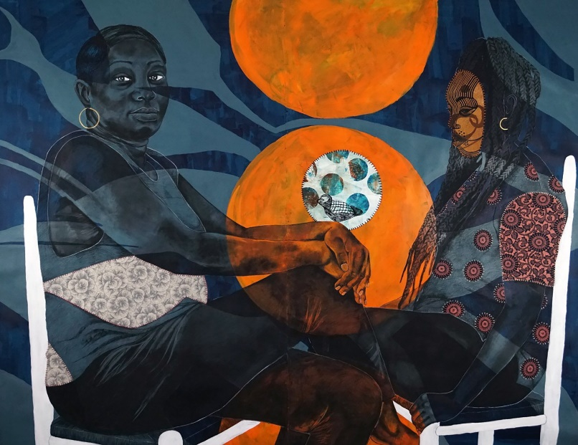  Big Idea:  Intentionality/Planning
Materials:  -Gelli Printing Plate  -Acrylic paint  -Brayer  -Baren  -Heavy Paper  -Access to a sink for cleaning  -A glass or plexiglass palette (optional) | Vocabulary:  -Monoprint  -Positive space  -Negative space  -Complementary colors  -Monochromatic color scheme  -Printmaking | Scaffolding Assignments:  Intro:  The teacher will introduce the lesson using google slides. Then, the teacher will demonstrate how to do a couple printing techniques using supplied objects. Students can later use these for their own printing process.  Since this is likely for an introductory class, the teacher will also briefly cover color schemes as part of the design process.  Research:  Students may look up examples for inspiration on their chrome books prior to starting.  They will also sketch a few compositions using their objects to get an idea of how the placement will look.  During the fall semester I might take well behaved classes outside to collect leaves as botanical themes are popular for gelli printing.  To choose color schemes, students can mark test schemes in their sketchbooks using the class sets of colored pencils.  Monoprinting: Layering Techniques and Composition.  Students will use gelli printing plates to create an asymmetrical composition with a color scheme of their choice. Once the preliminary work is complete, they will layer and print a final print to be turned in for a final grade. | Summative Assessment:  Students will plan a composition of found objects, and an accompanying color scheme. Then, they will use gelli printing techniques to create a monoprint with at least 2 layers to practice this printmaking technique.

Standards: 7.2 The student will apply steps of a creative process.
a) Use, and record in a digital or traditional sketchbook/journal, steps of the creative process, including research to create works of art
7.15 The student will refine media techniques to demonstrate developing technical skill.
Lesson Rationale:
Students will understand the importance of creating a compositional plan before creating a work of art. While the process of printing is relatively quick, the success of the print is largely predicated on the intention/message conveyed through the elements and principles of the work overall.

Process Photos:
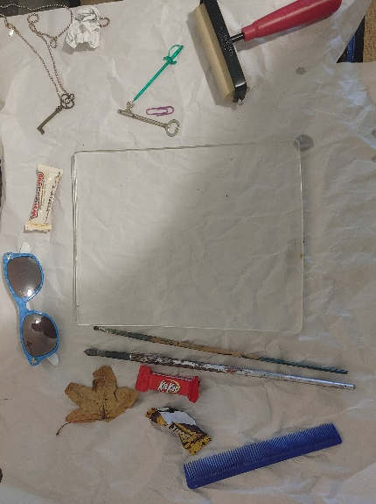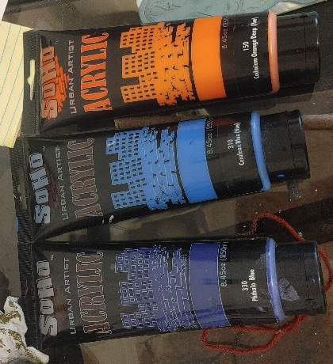

Step 1: Gather supplies including a brayer, a baren (a mason jar works), objects to print, a Gelli plate, acrylic paint, and a glass/Plexiglas palette.
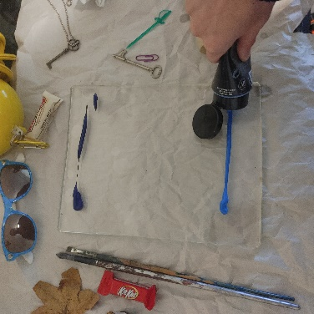
Step 2: Pour a little bit of acrylic on the plate.
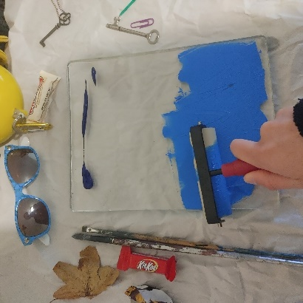
Step 3: Roll out the paint evenly on the plate.
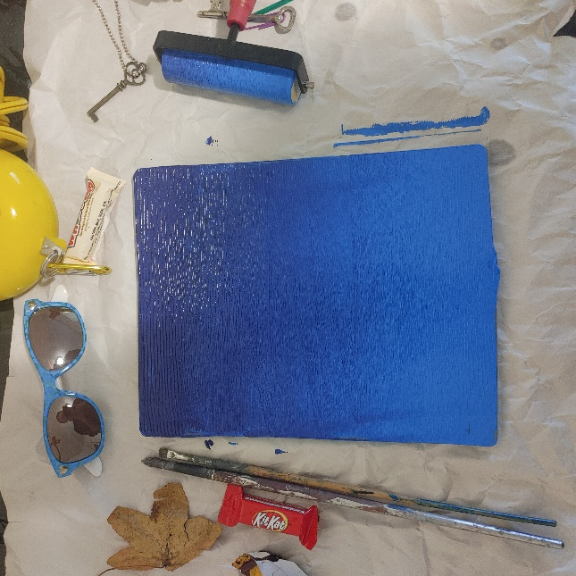
Step 4: evenly blend the paint for a gradient effect.
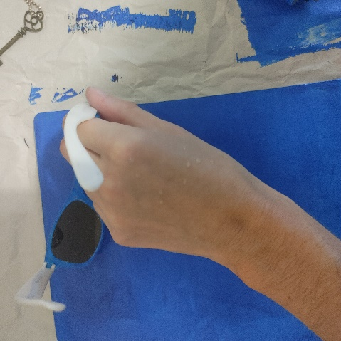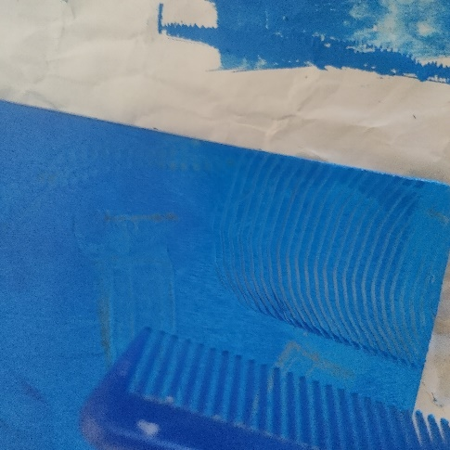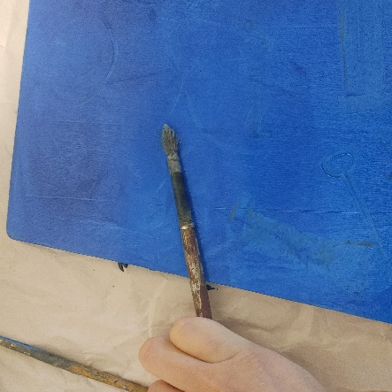
Step 5: Gently press objects into the wet paint. Make sure they are not sharp and will not damage the plate.
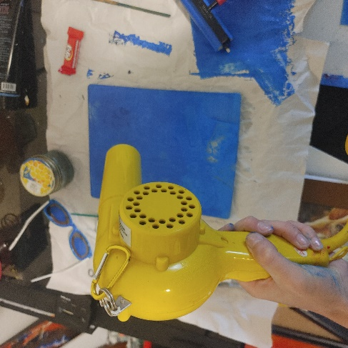
Step 6: Dry this layer before adding the next color.
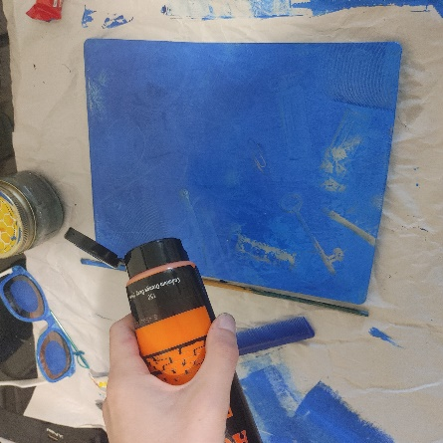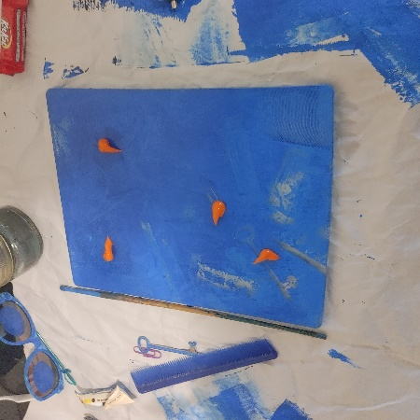
Step 7: Apply a little bit of he next color a little bit at a time.
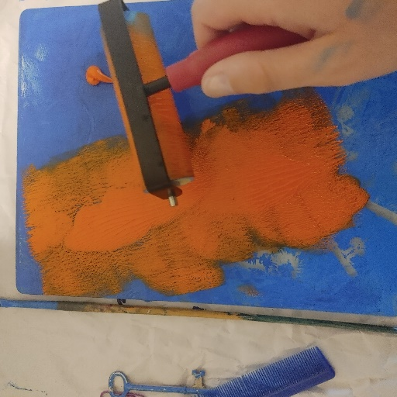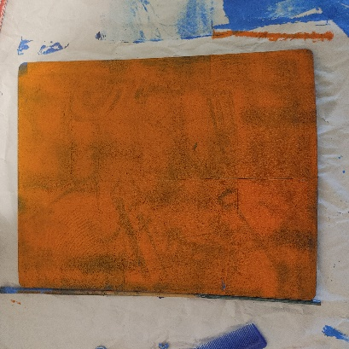
Step 8: Roll out the next color evenly onto the Gelli plate.
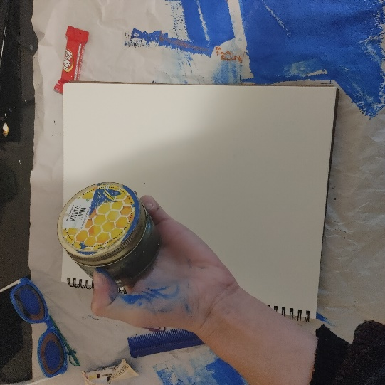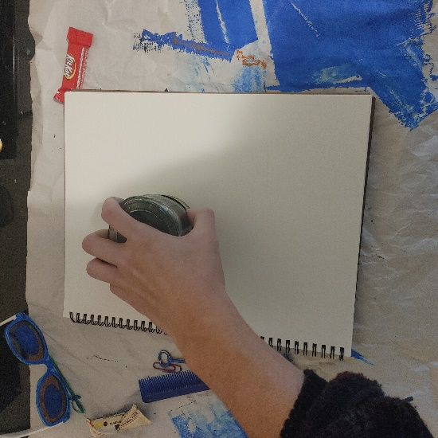
Step 9: Gently apply paper, you can use a mason jar as a baren. Apply even pressure to make sure everything transfers from the plate to the paper.
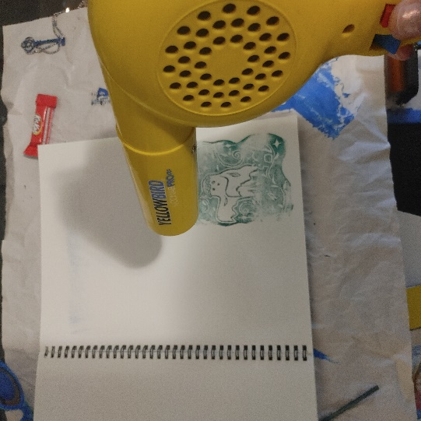
Step 10: Dry it for good measure. (optional)

Step 11: Gently remove paper to reveal the monoprint. This process can be redone in the opposite colors too

References
Schukei, A. (2020, October 5). 9 Printmakers You and Your Students Will Love. The Art of Education University. https://theartofeducation.edu/2020/10/october-9-printmakers-to-inspire-learning/.

Sonheim, C. (n.d.). About. Carla Sonheim Presents. Retrieved November 5, 2023, from https://www.carlasonheim.com/about/

